**Statistical Analysis Report into Demographic Trends in Grade of Colorectal Cancer in the UK**

A Blakemore

BSc Mathematics, UWE

# **Introduction**

Colorectal cancer (CRC) poses a significant health concern in the UK, with approximately 42,900 new cases diagnosed annually, making it 4th most common cancer. The introduction of the Bowel Cancer Screening Program (BCSP) in 2006 has been vital in improving the outcomes and mortality of CRC by its earlier detection. Previous analysis of Demographic trends by the NHS have been deduced a target population of men and women aged 60 to 74, with future screening ages start at 50. Although incidence rates have stabilized since the early 1990’s, mortality rates have increased by 11% likely due to the BCSP.

It is well known CRC has higher incidence in men, with around 23,900 new cases every year (2016-2018). The most common site being the rectum. Socioeconomic factors such as deprivation influence incidence rates, with higher rates observed in males from more deprived areas. Additionally, incidence rates are lower among Black, Asian and Mixed ethnic groups compared to the White population.

The stage of cancer is graded using a number grading system in which:

* Stage I – denotes cancer that is small and hasn’t spread anywhere.
* Stage II – the cancer has grown but hasn’t spread.
* Stage III – the cancer is larger and may have spread to surrounding tissues and/or the lymph nodes.
* Stage IV – the cancer has spread from the colon or rectum to at least one other organ.

This report aims to examine demographic trends in the incidence of CRC, such that early detection and prevention is ensured for the right people.

# **Methods**

### **Data**

Data consists of 95,326 anonymous patients diagnosed with CRC in the UK, aged over 20 years old.

### **Statistical Analysis**

SPSS Statistics 29 was used to analyse grade trends according to age, sex, ethnicity, income deprivation quintile and site. Initial overview analysis includes descriptive statistics and chi-squared ($χ^{2}$) test for association. A seven-point moving average analysis of site and age concluded the data fit a non-homogenous regression space, thus analyses were split into four data sets: grade incidence for 60 and over with colon cancer, under 60 colon cancer, and incidence of 60 and over with rectal cancer and under 60 with rectal cancer.

Since each variable does not have identical effect at each grade of cancer, the proportional odds assumption for an ordinal regression is not satisfied; a binomial logistic regression was used.

We will therefore consider two models:

* Model 1: Stage I vs Stage II, III and IV combined
* Model 2: Stage I, II and III combined vs Stage IV

A receiver operating characteristic (ROC) curve area under curve (AUC) was used to estimate the goodness of fit of the regression models predicted compared to observed data (0.5 is a model with predictive accuracy the same as chance, and 1.0 is a model with perfect predictive accuracy).

# **Results**

From the 95,326 patients with CRC, 16,667 had Stage I cancer, 25,370 had Stage II cancer, 28,694 had Stage III cancer and 24,595 had Stage IV cancer. Colon cancer was the most abundant with 65.8% of cases. The data consisted of 96.3% White and 56.7% Male.

### **60 and over Colon Cancer Trends**

For 60 and over colon cancer, there is a significant relationship ($χ^{2}$) between all variables and Stage of cancer (p<0.001).

**Table 1. Model 1: Demographic Odds ratio for 60 and over Colon Cancer Patients in the UK**

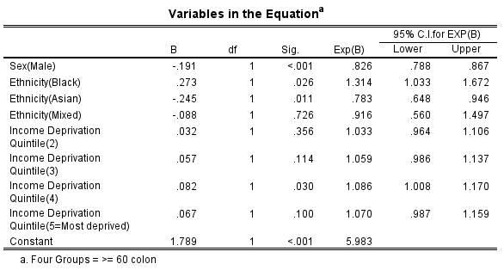

Of those 60 and over with Colon cancer the odds of having Stage I cancer for women is 1.21(C.I. 1.15 to 1.27) times greater than for men. The odds for black people is 1.31(C.I. 1.03 to 1.67) times greater than for white people, whereas the chances for Asian people are 0.78(C.I. 0.65 to 0.95) times less than for white people. Furthermore, those in the 4th income deprivation quintile are 1.09(C.I. 1.01 to 1.17) times more likely to have Stage I cancer than the least deprived. This model has predictive accuracy greater than chance with an AUC measure of 0.53.

**Table 2. Model 2: Demographic Odds ratio for 60 and over Colon Cancer Patients in the UK**

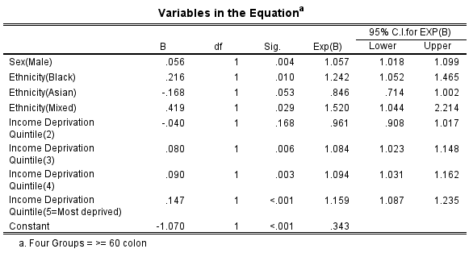

Of those 60 and over with Colon cancer the odds of having Stage I, II or III cancers combined for men is 1.06(C.I. 1.02 to 1.10) times greater than for women. The odds for black people is 1.24(C.I. 1.05 to 1.47) times greater than for white people, and the chances for mixed people are 1.52(C.I. 1.04 to 2.21) times more than for white people. Furthermore, those in the 3rd income deprivation quintile are 1.09(C.I. 1.02 to 1.15) times more likely, those in the 4th income deprivation quintile are 1.10(C.I. 1.03 to 1.16) times more likely, and those in the 5th income deprivation quintile are 1.16(C.I. 1.09 to 1.24) times more likely to have Stage I, II or III cancers than the least deprived. This model has predictive accuracy greater than chance with an AUC measure of 0.522.

### **Under 60 Colon Cancer Trends**

For under 60 colon cancer, there is a significant relationship ($χ^{2}$) between grade of cancer sex (p=0.028) and income deprivation (p=0.007) with Stage of cancer, although there is no significant relationship with age (p=0.144) and ethnicity (p=0.089).

**Table 3. Model 1: Demographic Odds ratio for Under 60 Colon Cancer Patients in the UK**

Of those under 60 with Colon cancer the odds of having Stage I cancer for those in the 4th and 5th income deprivation quintile are 1.46(C.I. 1.18 to 1.81) and 1.24(C.I. 1.0 to 1.53) times, respectively, more likely than those in the least deprived income quintile. This model has predictive accuracy greater than chance with an AUC measure of 0.538.

**Table 4. Model 2: Demographic Odds ratio for Under 60 Colon Cancer Patients in the UK**

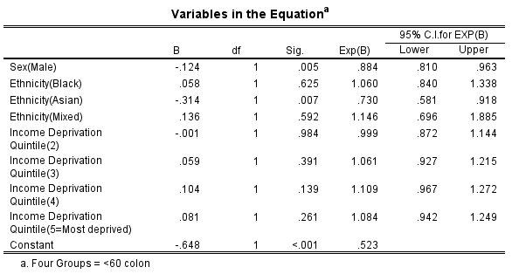

Of those under 60 with Colon cancer the odds of having Stage I, II or III cancers combined for women are 1.21(C.I. 1.15 to 1.27) times greater than for men. This model has predictive accuracy greater than chance with an AUC measure of 0.526.

### **60 and over Rectal Cancer Trends**

For 60 and over rectal cancer, there is a significant relationship ($χ^{2}$) between grade of cancer and age (p<0.001), ethnicity (p=0.011) and income deprivation (p<0.001), although there is no significant relationship with sex (p=0.077).

**Table 5. Model 1: Demographic Odds ratio for 60 and over Rectal Cancer Patients in the UK**

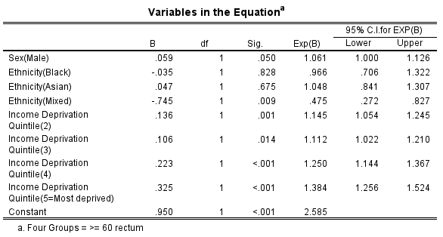

Of those 60 and over with Rectal cancer the odds of having Stage I cancer for white people is 2.10(C.I. 1.21 to 3.68) times greater than for mixed people. Additionally, those in the 2nd, 3rd, 4th and 5th income deprivation quintiles are 1.15(C.I. 1.05 to 1.25), 1.11(C.I. 1.02 to 1.21), 1.25(C.I. 1.14 to 1.37) and 1.38(C.I. 1.256 to 1.524) times, respectively, more likely to have Stage I cancer than those in the least deprived income quintile. This model has predictive accuracy greater than chance with an AUC measure of 0.531.

**Table 6. Model 2: Demographic Odds ratio for 60 and over Rectal Cancer Patients in the UK**

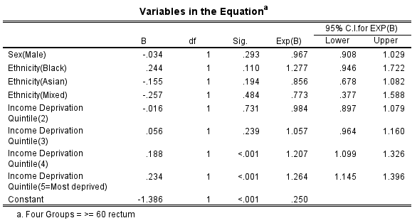

Of those 60 and over with Rectal cancer the odds of having Stage I, II and III cancers combined for those in the 4th and 5th income deprivation quintile are 1.21(C.I. 1.01 to 1.33) and 1.26(C.I. 1.15 to 1.40) times, respectively, more likely than those in the least deprived income quintile. This model has predictive accuracy greater than chance with an AUC measure of 0.528.

### **Under 60 Rectal Cancer Trends**

For under 60 rectal cancer, there is a significant relationship ($χ^{2}$) between grade of cancer against sex (p<0.001), although there is no significant relationship with age (p=0.245), ethnicity (p=0.150) and income deprivation quintile (p=0.056).

**Table 7. Model 1: Demographic Odds ratio for Under 60 Rectal Cancer Patients in the UK**

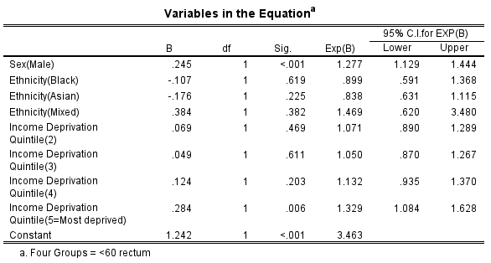

Of those under 60 with Rectal cancer the odds of having Stage I for men is 1.28(C.I. 1.13 to 1.44) times greater than for women, and those in the most deprived income quintile are 1.33(C.I. 1.08 to 1.63) times more likely to have Stage I cancer than the least deprived. This model has predictive accuracy greater than chance with an AUC measure of 0.545.

**Table 8. Model 2: Demographic Odds ratio for Under 60 Rectal Cancer Patients in the UK**

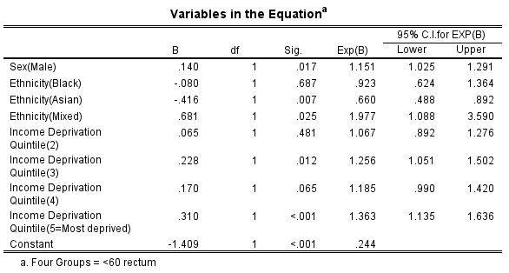

Of those under 60 with Rectal cancer the odds of having Stage I, II and III cancers combined for men is 1.15(C.I. 1.03 to 1.29) times greater than for women, and the odds for Asian and mixed people are 0.66(C.I. 0.49 to 0.89) and 1.98(C.I. 1.09 to 3.59) times, respectively, compared to white people. Furthermore, those in the 3rd, 4th and 5th income deprivation quintiles are 1.26(C.I. 1.05 to 1.50), 1.19(C.I. 0.99 to 1.42) and 1.35(C.I. 1.14 to 1.64) times, respectively, more likely than those in the least deprived income quintile. This model has predictive accuracy greater than chance with an AUC measure of 0.545.

# **Discussion**

Although men tend to higher incidence of all grades of CRC overall, women under 60 have greater odds of colon cancers of stage I, II and III which supports the notion that men generally do not have as much sense of self-care, as they do not get check ups until it is too late and cancer as progressed to Stage IV. Despite majority of cases being of rectal cancer, there is a disparity in Stage IV rectal cancer incidence compared to colon cancer, most likely due to the anatomical location of the rectum making early detecting more difficult, thus, although rectal cancer is less common, it is vital that those most likely to have rectal cancer get screenings early. There's a consistent trend across age groups and cancer types where individuals in higher income deprivation quintiles have higher odds of having certain cancer stages compared to those in the least deprived quintile.

# **References**

* ‘Bowel cancer screening: programme overview’ (no date) GOV.UK [online]. Available from: <https://www.gov.uk/guidance/bowel-cancer-screening-programme-overview#condition-screened-for>.
* Cancer Research UK (2015) Bowel cancer statistics Cancer Research UK. 14 May 2015 [online]. Available from: <https://www.cancerresearchuk.org/health-professional/cancer-statistics/statistics-by-cancer-type/bowel-cancer#heading-One>.
* NHS (2019) What Do Cancer Stages and Grades mean? NHS. 2019 [online]. Available from: https://www.nhs.uk/common-health-questions/operations-tests-and-procedures/what-do-cancer-stages-and-grades-mean/.